Task 1: Ordering fractions, decimals, and percentages. *Calculator allowed!
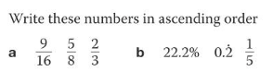

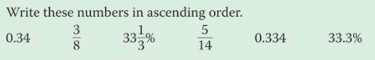

Task 2: Identifying terminating and recurring decimals.
*No calculator allowed!

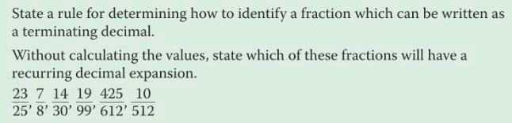

Task 3: Rewriting recurring decimals. *No calculator allowed!

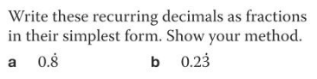

Task 4: Converting between fractions, decimals, and percentages.
You do not have to complete every problem, but do enough in each category until you feel confident in converting. *No calculator allowed!

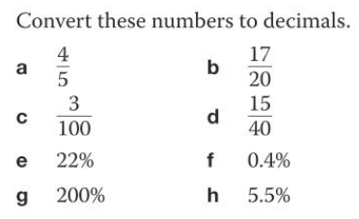

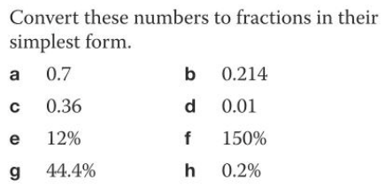

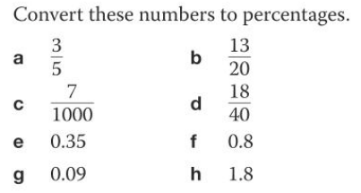

Task 5: Fraction/Percentage of a Quantity *Calculator allowed!

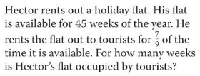

48% of students at a school are girls. 576 students are girls. How many students are there all together?

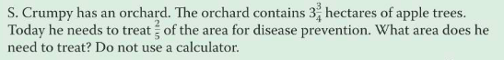

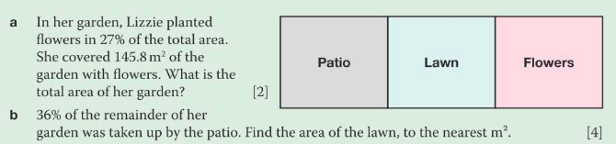

Task 6: Calculations with Fractions *No calculator allowed!

